

Some ways you can say
‘Thank You’

AWARDS IN GIRLGUIDING BUCKINGHAMSHIRE COUNTY

The aim of this leaflet is to bring together information on the Awards within Girlguiding Buckinghamshire County (or higher if appropriate) that can be made/recommended for service within the County, so that there can be greater clarity and understanding generally as to which Award might be appropriate when considering a nomination for recognition of service given or fortitude shown.

It should be remembered that Nominations for all the following Outstanding Service Awards should be made without the knowledge of the nominee or her relatives.

The County Awards group consists of:
County Commissioner
Assistant County Commissioner(s)
County Awards Chairman
County Awards Secretary
Any member as identified by the County Commissioner.

Nominations can be submitted at any time during a year and will be considered as soon as possible to enable a prompt decision to be made. Once the nomination has been considered, the Proposer (not the candidate) will be advised of the outcome, in confidence, by the Awards Secretary.

Successful nominations will result in the Award being passed to the appropriate Commissioner for award at the earliest opportunity at a suitable occasion. Our County Commissioners aim to present long service awards for 30, 40, 50 and 60 years whenever possible. They would also like to be present when other Good Service or Thank You Awards are being presented.

Forms to make nominations are available on the County website or from the County Office.

For consistency of information, please use the forms provided on the county website or on request from the county office.

Long Service awards

Long service - Girlguiding wishes to recognise everyone's contribution to guiding.

Any adult member who volunteers regularly, irrespective of role, gender or age, is eligible for a Long Service Award. Service will be counted from the date the individual becomes a member, aged 16 or over, and actively carries out a role for 5, 10, 20, 30, 40, 50 or 60 years (not necessarily consecutively).

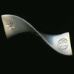
The Long Service award brooches are all of similar design with different finishes and metals signifying the years. All the brooches are accompanied by a certificate.

- The 5-year certificate is signed by the County Commissioner
- 10 and 20-year certificates are signed by the Country or Region Chief Commissioner
- 30, 40, 50 and 60-year certificates are signed by the Chief Guide.

The brooches may be worn on the badge tab or on non-guiding clothing.

It is the responsibility of the county commissioner to establish when active members in their county are due to receive awards and to present them appropriately. If there is any query about length of service, the decision of the county commissioner is final.
The County Awards Group do their best to issue these, as are due, on a quarterly basis so members are not required to request these unless they think they are overdue.

Cloth versions of long service awards
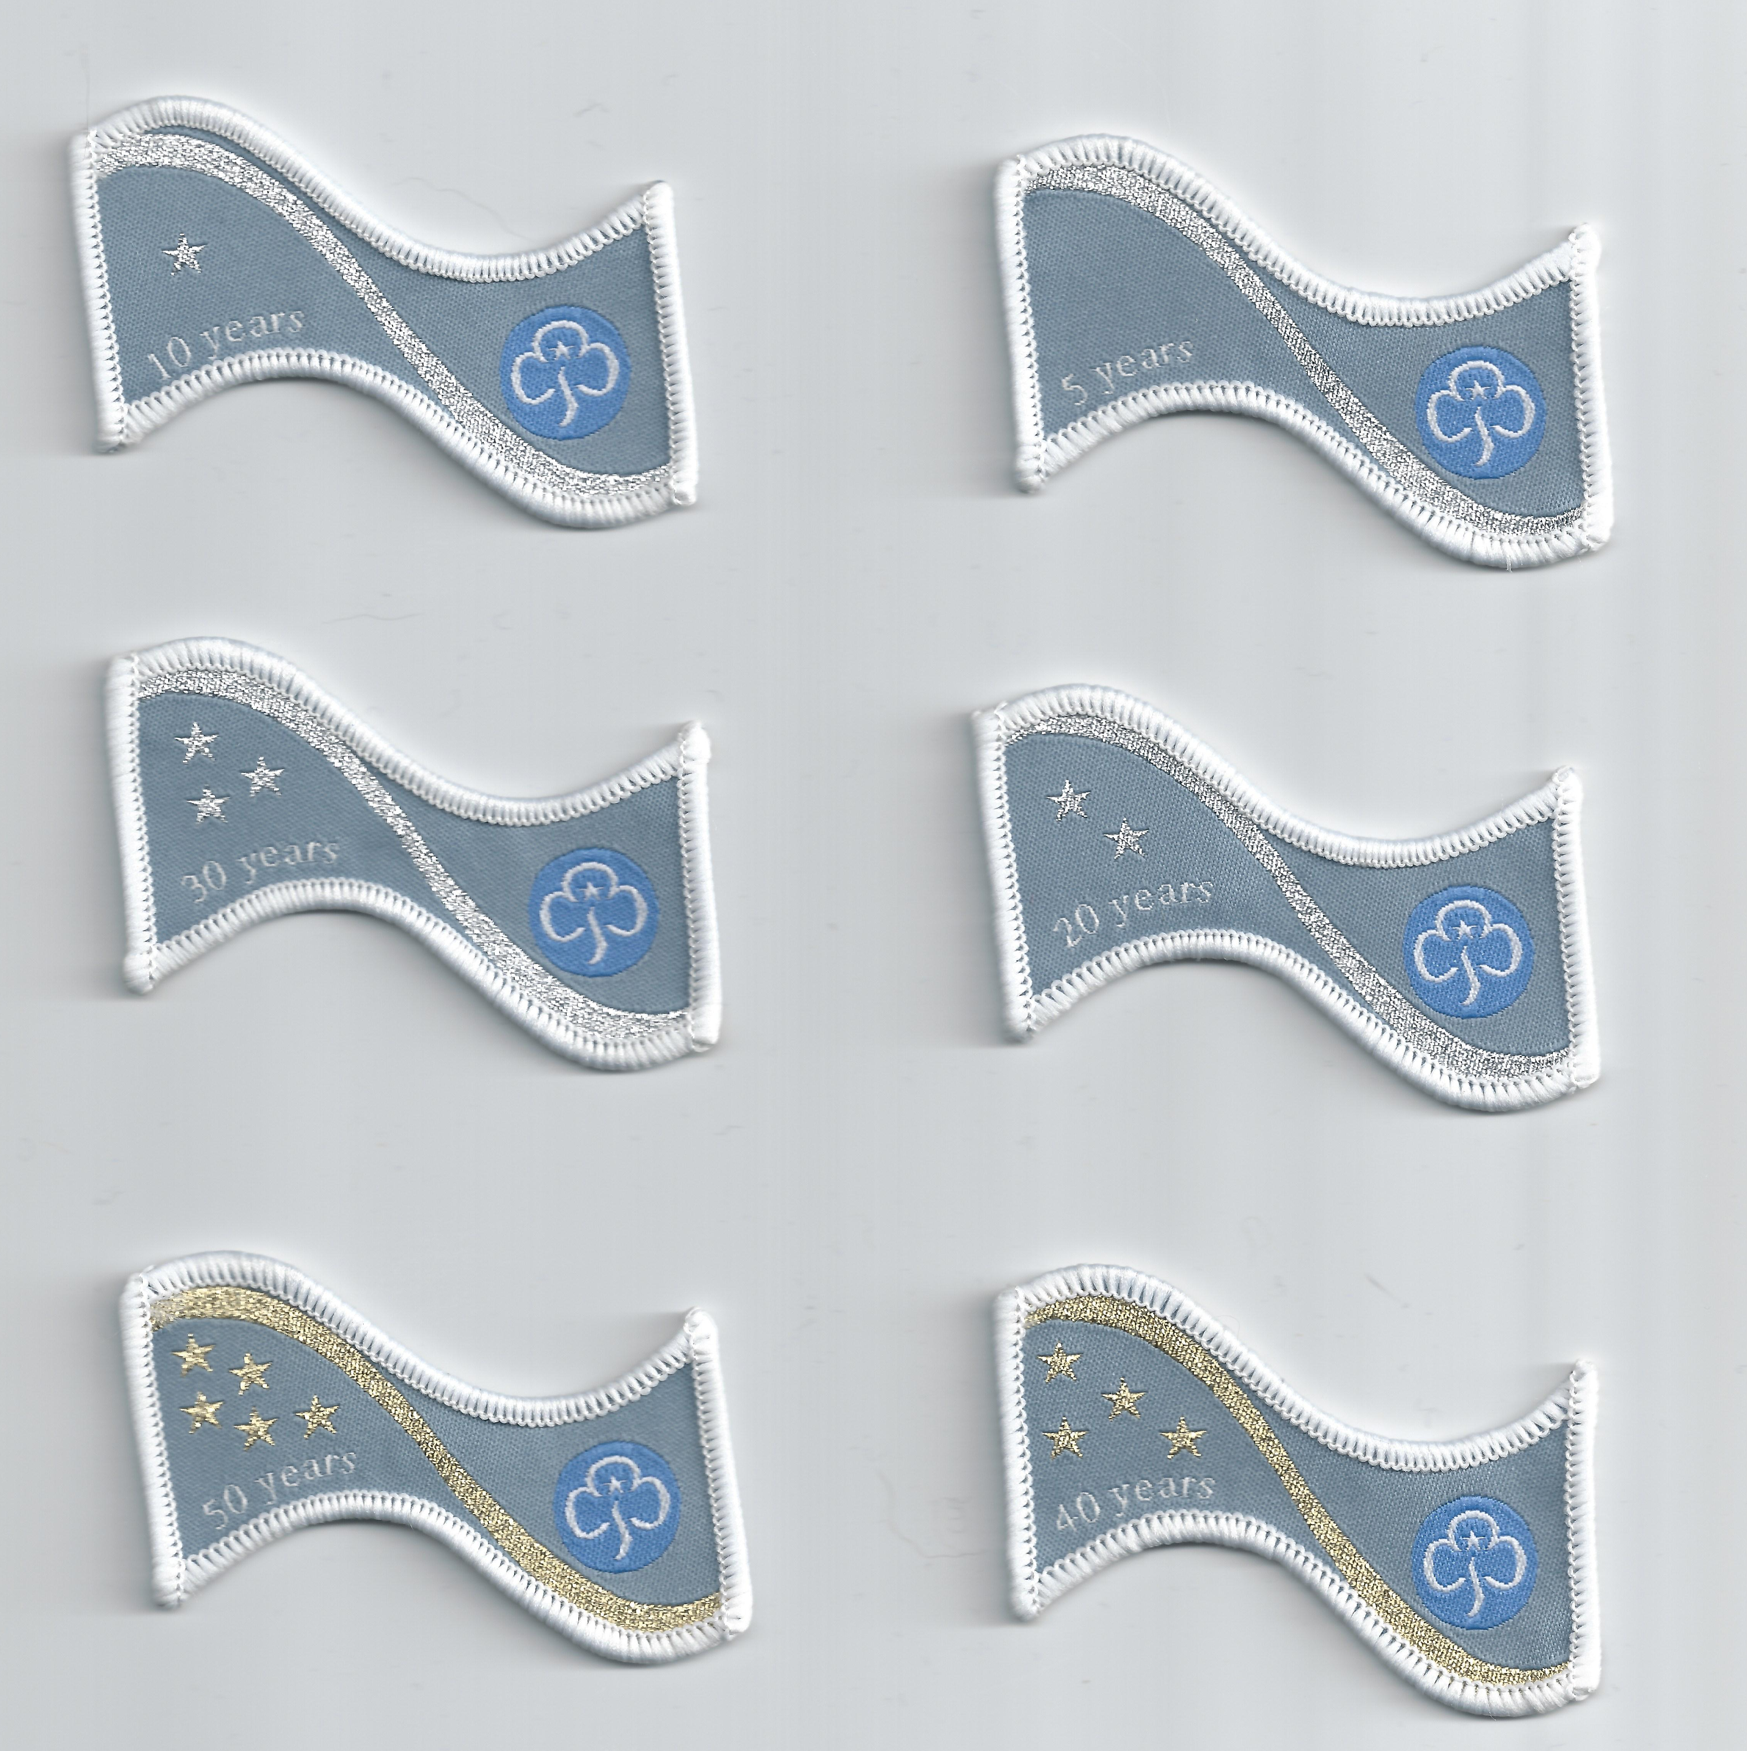
Cloth versions of the brooches are available from the County Awards team on request via the County Office. These can be worn out of uniform or used to decorate camp blankets. The cost of these is a personal responsibility.

AWARDS THAT CAN BE GAINED THROUGH COUNTY

GOOD SERVICE BROOCH AND CERTIFICATE

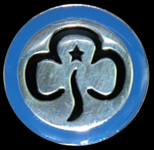

This brooch may be given to an adult member of Girlguiding for excellent service to guiding. It can be awarded by:

- the chief guide, for service to Girlguiding or a Branch Association
- a chief commissioner, for service in a country or region.
- a county commissioner, for service in the county

To be eligible for a Good service brooch the nominee must fulfil one of these criteria:

- hold a current member and recognised volunteer card
- have completed a role no more than six months before the application is made

The Good service brooch is silver metal with blue enamel. It is accompanied by a certificate

Use the award nomination form available on the County website or from the County Office.

COUNTY GOOD SERVICE CERTIFICATE

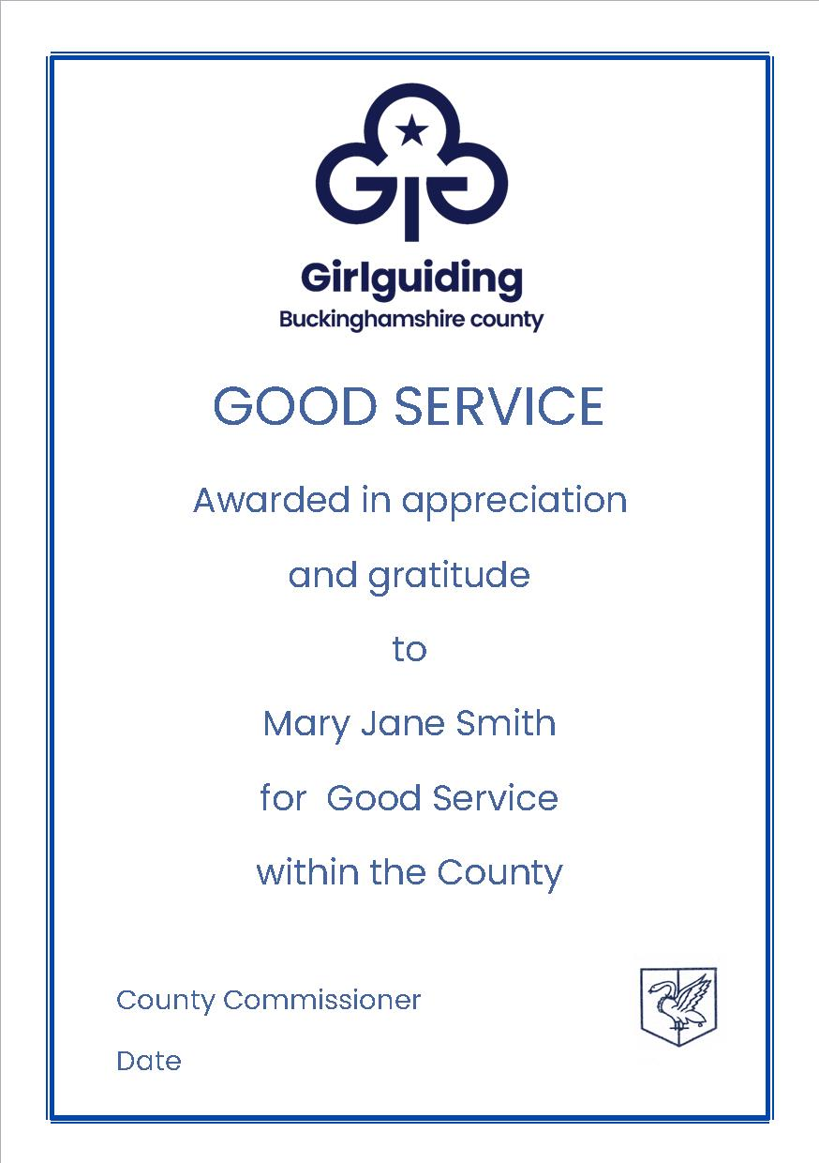

The County Good Service Certificate can be awarded to any adult member of Girlguiding Buckinghamshire County.

This can be awarded to a person whom the County Awards group Committee considers merits this award for their dedication and devotion to duty, and to have demonstrated a commitment and level of service, which has been over and above ‘the call of duty’.

Use the award nomination form available on the County website or from the County Office

COUNTY THANK YOU CERTIFICATE

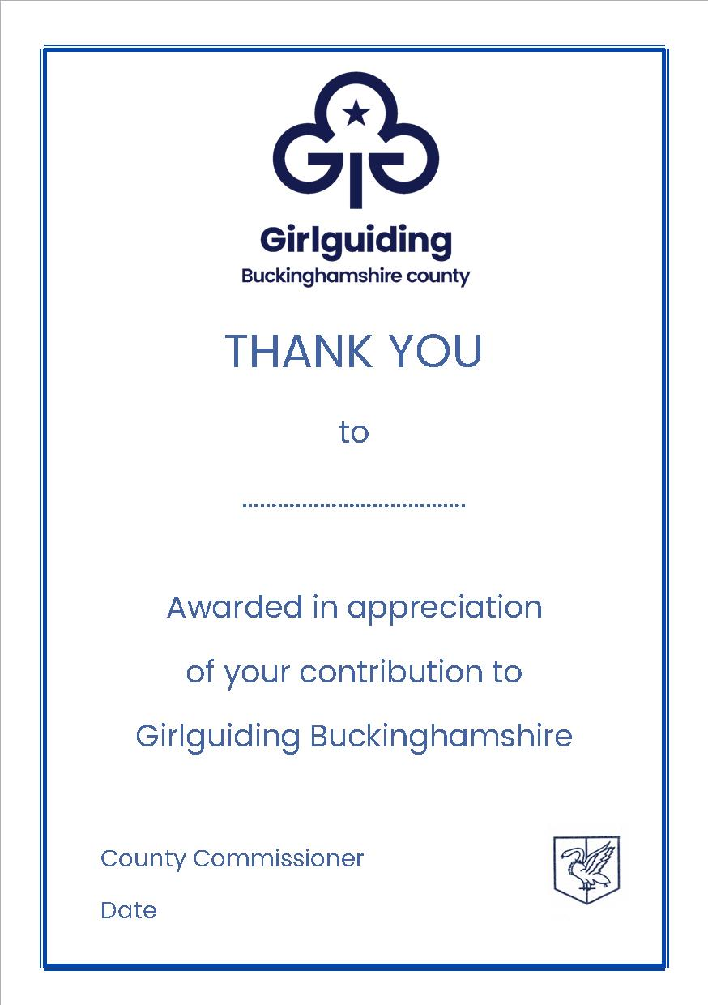

The County Thank You Certificate can be awarded to any person who has contributed to Girlguiding Buckinghamshire County a commitment and action, which has or will be a benefit to our members, either for a specific event or over a period of time. This certificate may be given to an adult member or non-member of the Association.

Use the award nomination form available on the County website or from the County Office

COUNTY CERTIFICATE OF MERIT

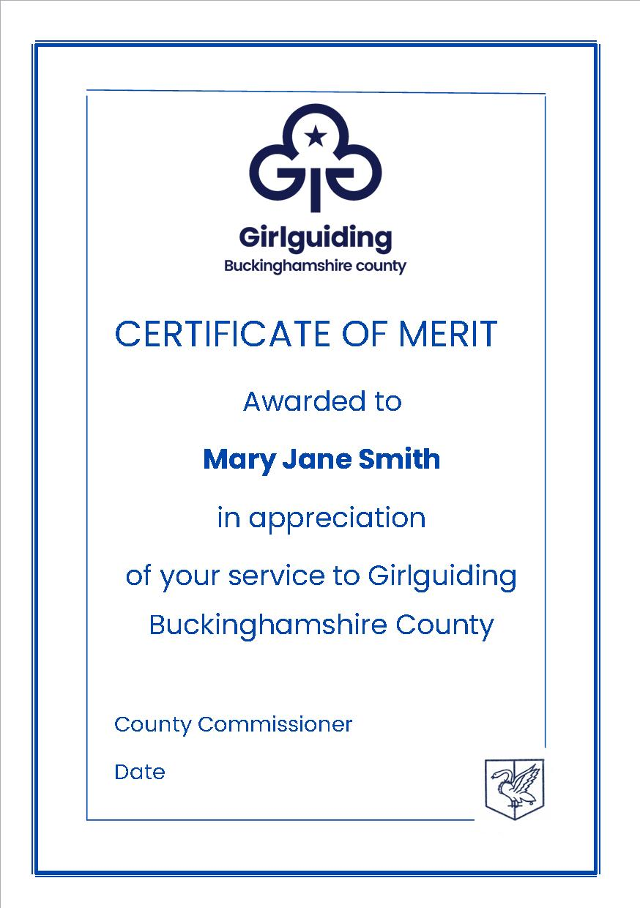

The County Certificate of Merit can be awarded to any member who has contributed to Girlguiding Buckinghamshire County a commitment which has or will be benefit to our members whilst at the same time coping with personal difficulties, (e.g. personal illness or adverse situations with close family). Alternatively, this certificate may be given to any member who has contributed a commitment that will be a benefit to others (not necessarily associated with the County) and in doing so, has represented Girlguiding in a positive way.

This certificate may be given when the nominee does not warrant a County Good Service Certificate but has shown courage, selflessness and devotion to duty in circumstances when it would have been easier to give up his or her commitment to Guiding.

Applications for the Certificate of Merit can be submitted at any time, and when life expectancy is poor, will be considered outside the Award Group meetings.

Use the award nomination form available on the County website or from the County Office.

THE THANKS BADGE

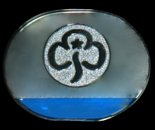

- The Thanks badge can be either a brooch or lapel pin given to members and non-members of Girlguiding as a sign of appreciation for their support

- Any member of Girlguiding may present a Thanks badge after discussion with a leader or commissioner

- The Thanks badge may only be given to a member of the Trefoil Guild if they have given service specifically to Girlguiding

GIRLGUIDING ANGLIA REGION AWARDS

For more information visit www.girlguiding-anglia.org.uk. To submit a nomination please firstly contact your county awards chairman as all nominations must be supported, in the first instance, by your county awards committee.

ANGLIA BROOCH

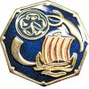

The Anglia Brooch is awarded for commitment and level of service above 'the call of duty', notable display of courage, bravery or initiative.

ANGLIA BIG THANK YOU CERTIFICATE AND BROOCH

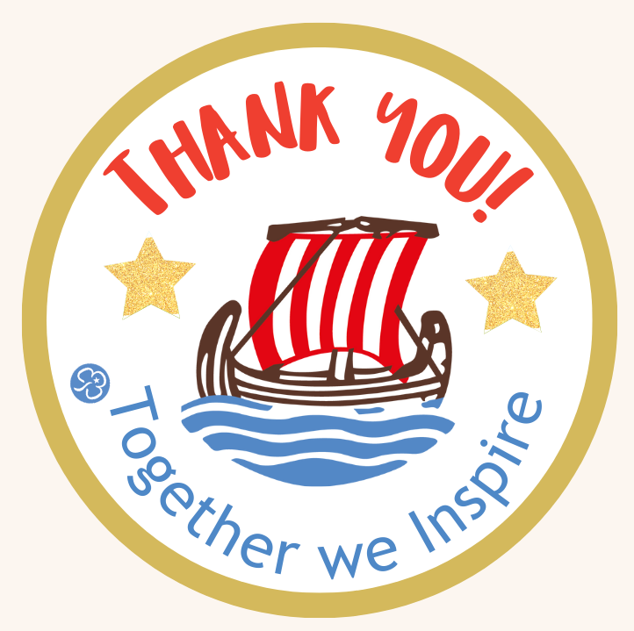

This certificate is designed to thank any member, adult or child, or non-member who has positively impacted guiding. There are no parameters or criteria for this particular certificate as everyone deserves a thank you.

ANGLIA YOUTH AWARD

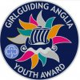

This Girlguiding Anglia award is for young members who have shown exceptional commitment to Girlguiding or made a notable difference to others through a variety of means.

The Anglia Youth Award and certificate can be awarded to a young person who is:
• A member of Girlguiding Anglia,
• Under the age of 18.

BUDDY AND UNIT BUDDY AWARDS

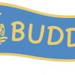

This recognises young women in guiding who act as buddies, supporting their peers with additional needs within units, at events or on camps and holidays.

Details how to apply together with the relevant Application Forms for all Anglia Region Awards are available at the Girlguiding Anglia website: www.girlguiding-anglia.org.uk

GIRLGUIDING UK DISCRETIONARY AWARDS

For more information visit www.girlguiding.org.uk.

THE HERO CERTIFICATE

An award for members or friends of Girlguiding who have done something special.

Members can also be nominated for the following discretionary awards:

- Guiding Star
- Laurel award
- Silver Fish

All nominations for National Awards must be sent in using the current and appropriate nomination forms to the County Awards Committee (via the County Office). If you need any further information or guidance on nominating someone for this award, please do not hesitate to contact the Chairman of the County Awards Committee (via the County Office). Please see the Girlguiding website and Guiding Manual for details of the criteria for these awards. The website also offers advice on guidelines for making an application and the letters of support. (The keywords to look for when searching for this information are “Thanks and Recognition”)

THE LAUREL AWARD – CELEBRATING EXCEPTIONAL SERVICE

An award for active adult members of Girlguiding.
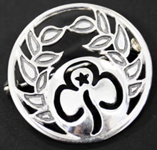

Award criteria

- Guiding experience - the member should have held a number and variety of roles within their District/Division/County or beyond. Within these roles the member should have demonstrated outstanding leadership skills and have been an effective team member.

- Impact - the member should have made a significant contribution to supporting and developing guiding for both girls and adults.

- Personal attributes - the member should be a person who is respected by their guiding peers, ‘stands out’ and has made a significant difference to guiding.

Guidelines for making an application can be found at:
www.girlguiding.org.uk

THE SILVER FISH – recognising what a member has achieved across the breadth of Girlguiding.

The award is for an exceptional contribution to a wide section of Girlguiding, including international guiding either in the United Kingdom or abroad. This award may be given to an active adult member of Girlguiding or one of the Branch Associations.

Only a small number of these awards are granted.

Award criteria

The application should reflect the nominee’s outstanding service, which must be of an exceptionally high standard.

- Guiding experience - the member should have held a range of roles in guiding at District/Division/County levels and beyond. Within this range of roles the member should have demonstrated excellent leadership skills and made significant contributions as a team member.
- Impact - the member should have made a significant contribution to supporting, motivating, nurturing and developing guiding for both girls and adults. This should be over a range of roles, both locally and internationally.
- Personal attributes - the member should be outstanding and an exceptionally high achiever who is always ready to take on a challenge - someone who makes things happen, and who inspires and motivates people.
- International - it's not essential for the member to have travelled abroad. However, their work should demonstrate a major contribution to guiding in other countries, resulting in the strengthening of guiding relationships between countries.

Guidelines for making an application can be found at:
www.girlguiding.org.uk

The Guiding Star - rewards bravery and determination in challenging situations

An award for any member of Girlguiding, up to her 26th birthday, who has displayed exceptional courage or who has shown great initiative or responsibility during an incident.

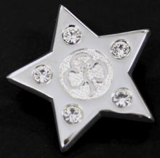

Award criteria

The Guiding Star Award may be given for:
- Saving or helping to save a life
- Bravery and competence in facing an emergency situation
- Caring for a sick relative
- Have made a significant contribution and impact on guiding in their unit or area whilst showing courage and determination in the face of a serious or long-term medical condition
- Have made a significant contribution and impact on guiding in their unit or area whilst coping with exceptional circumstances in life.

If the award application is based on an incident or emergency situation, this must have occurred within the last six months.

Further details on guidelines for making an application are available at:
www.girlguiding.org.uk

SUPPORTING INFORMATION - for all Awards

Nominations for all the above awards are to be forwarded using the appropriate nomination form, to the County Awards Chairman (via the County Office), and will be considered as soon as practically possible.

With so many adults giving good service to the Girlguiding, the Awards Committee has the difficult task of maintaining a high standard of Award Holders whilst at the same time ensuring no deserving nominee goes unrecognised. The supporting evidence is therefore of the utmost importance.

• The relevant section of the Nomination Form must be completed with a list of all appointments held and the dates. A copy of the candidates Go! Record should be used for this purpose and can be obtained from the County Office if necessary.

• Members of the Association, in addition to giving their personal assessment of the nominee, should give their reasons for considering the service given to be outstanding.

• It is helpful if information is giving regarding the conditions under which the nominee has or is giving her service, the type of area or community in which she does her Guiding, her influence on other members of the Movement – girls and adults – her involvement with specific projects or events, other commitments, any special achievements which have benefited Girlguiding Buckinghamshire.

• Nominations should be clearly written so that they are easily read, and all required information on the form completed as fully as possible.

PLEASE NOTE: Should a nomination be received from within County which the County Awards group considers worthy of a Girlguiding UK Award, the Chairman will contact the proposer to discuss this further with a view to changing the nomination accordingly.

If you need any further information, please contact:

Chairman of County Awards Committee:
c/o Girlguiding Buckinghamshire County Office
3 Walton Terrace
Walton Street
Aylesbury
Bucks HP21 7QY

Email: ggbucks@girlguidingbucks.org.uk

