Girlguiding Buckinghamshire
County Badge

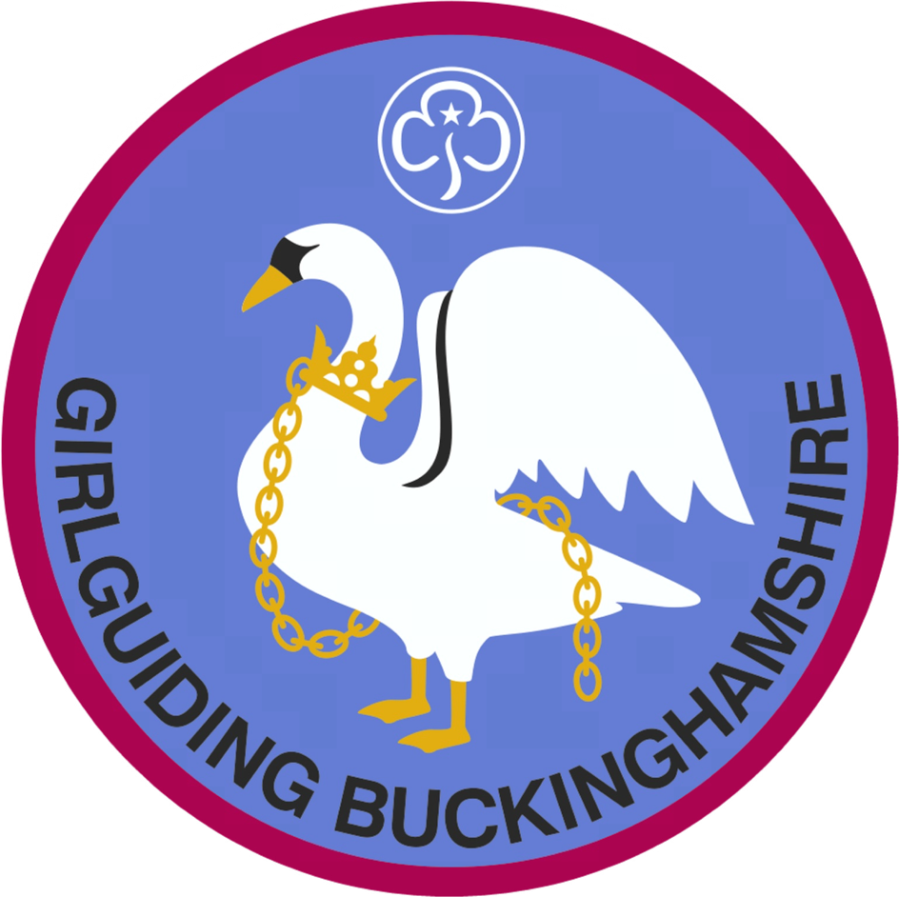

We have County Badges being sold to raise money for the Ellesborough Development Fund. Each badge costs £1.50.

For orders please email:
Pauline - merchandise@girlguidingbucks.org.uk

