Ellesborough badge order form
Orders to be placed and paid for 4 weeks before arrival date to allow postage time, (orders placed after this point may not arrive before booking)
Name:
Email:
Postage address:

Item | Price | Total ordered | Total Price
Ellesborough Buckinghamshire  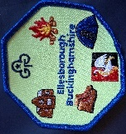 | £1.50
I camped at Ellesborough   | £1.50
I love Camping   | £1.50
I love Ellesborough   | £1.50
I’ve been on pack holiday at Ellesborough  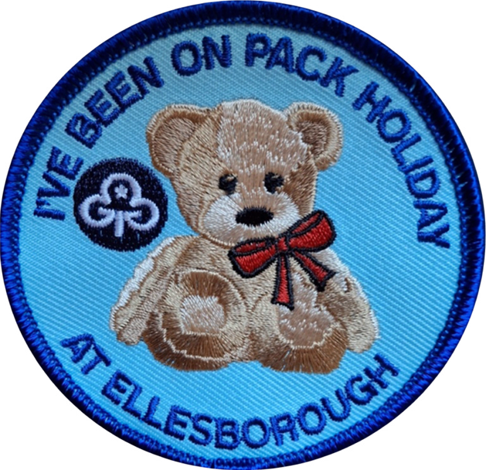 | £1.50
I Climbed Coombe Hill 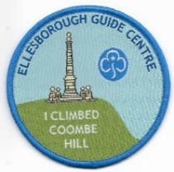 | £1.50
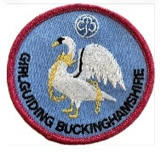  Girlguiding Buckinghamshire | £1.50
Ellesborough Guide Centre (round)  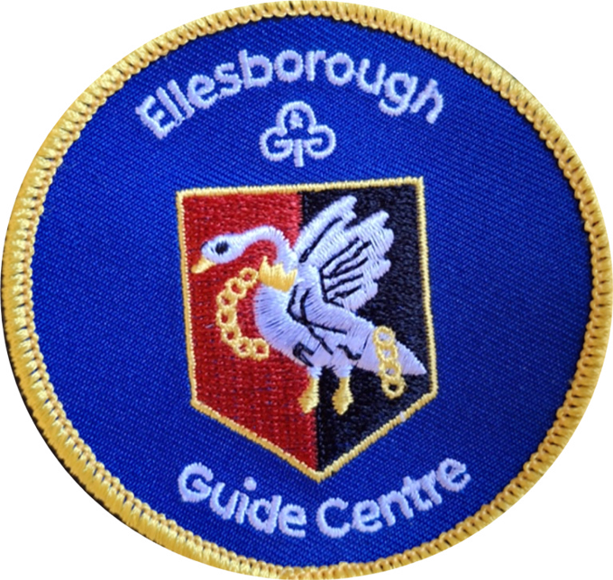 | £1.50
Ellesborough Guide Centre Buckinghamshire -Rectangular  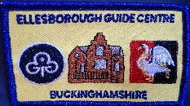 | £1.50
Postage and Packing | Up to 50 badges £2  Over 50 badges £3.60
 |  | Total to pay

Please email your order form to: ggbucks@girlguidingbucks.org.uk

An invoice and details of how to make your payment will then be sent.

