WOVEN SERVICE BADGES
Available from your County Awards Secretary, holders of long service brooches are eligible to apply for these badges which can be sewn onto informal clothing or camp blankets.

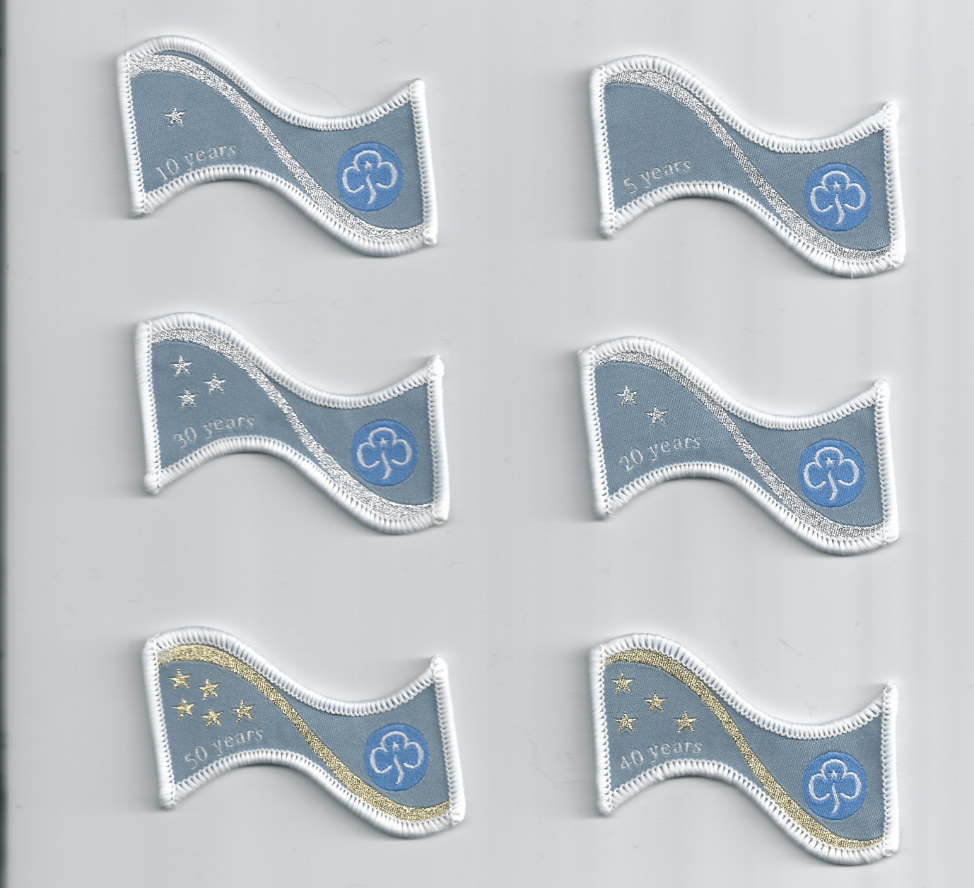

Name:.................................................................................................
Adddress:.............................................................................................
................................................... ......................................................
Contact email/Tel No.......................................Membership No.....................
What badge required – ie 5yr, 10yr, 20yr, 30yr, 40yr, 50yr No. required………………………
The cost of each badge is £1.50. plus postage of £1.00 for up to 3 badges, if ordering any more please contact the office for a price: ggbucks@girlguidingbucks.org.uk Payment can be made by Cheques - payable to Guide Assn of Bucks or via direct deposit to Account No.: 83402950 Branch code: 60.11.01 account name: Guide Association of Bucks – Ref.: W. Badge. If paying by bank transfer please complete, once payment has been made, the address box below of where the badges need to be sent:
Address to send badges to.

Attention: Pam Scott
Girlguiding Bucks, County Office
3 Walton Terrace
Walton Street
Aylesbury
HP21 7QY

Any queries contact Pam Scott by email: pamscott949@gmail.com

