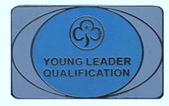
Young Leader Qualification
Congratulations

Young Leaders who completed the YL Qualification 01.07.2023 to 31.09.2023
Sophie Bradley | 1st Aston Clinton Rainbows
Louise Brown | 4th Wendover Brownies
Emily Carrivick | 1st Fenny Stratford Brownies
Ruby Dover | 1st Aston Clinton Rainbows
Amy Pope | 1st Aylesbury Rainbows
Charlotte Prescott | 2nd Halton Brownies

If you want to do the YLQ look at https://www.girlguiding.org.uk/get-involved/become-a-volunteer/young-volunteers/young-leader/
Ask your Unit Leader/Commissioner to put on GO the fact that you are doing the YLQ.
A new syllabus will be available in Summer 2024 but you still have plenty of time to get started now, and will have until Summer 2025 to complete it.

